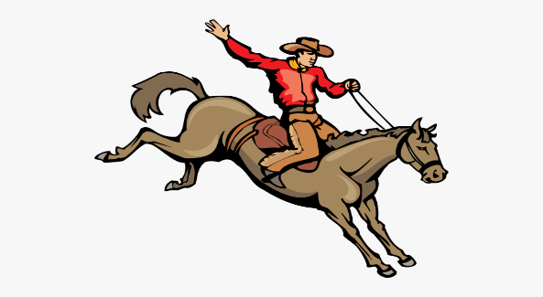

2024-2025 Bowring Wrangler Basketball Schedule

Nov. 11 Wesleyan Home 5:30

Nov. 12- 16 Shidler Tournament

Nov 21 Wesleyan Away 6:00

Dec 3 Copan Home 5:30

Dec 5 Osage Hills Home 5:30

January 6-11 Bowring Tournament

January 16 Osage Hills There 5:30

January 30 Copan There 5:30

February 1 ORES Basketball Playoffs